Kerrilyn Merino & Poll Merino Stud

For Sale at Australian Sheep & Wool Show 2021 & bendigo Auctions Plus on-line Sale, Sunday 18th July @1.00pm

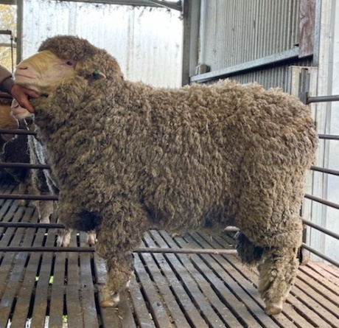  Tag 19.T107 | 19.T107 is a AI bred son of Mulloorie Elliot and was a member of our 2020 pen of 3 at Loddon Valley. For a twin reared lamb, it is unusual to be picked out at a young age. Has an exceptional testing long stapled fine, medium fleece and a great dual purpose body.  Tag No 19.T107  Sire Mulloorie Elliot  Micron SD CV CF  19 2.5 13.2 99.9 | 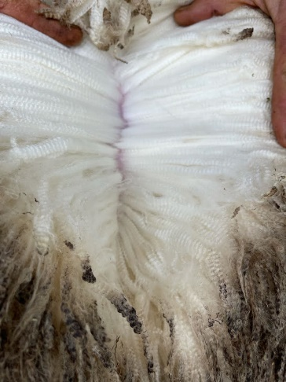
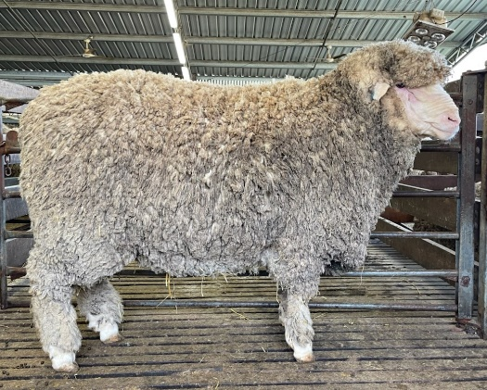  tag 19.48 | 19.48 is another AI son of Mulloorie Elliot and has a good testing medium wool and a great square stance. Has a rear end any meat breed would be proud of.  Tag No 19.48  Sire Mulloorie Elliot  Micron SD CV CF  21.5 3 14 99.4 | 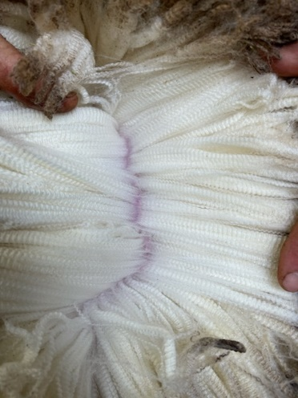
tag 19.80  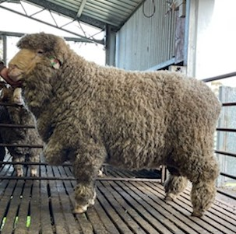 | 19.80 has a very long and deep body and a sire’s big boof head. Sired by our Mount Youlong sire over a South Australian Lambex ewe.  Tag No 19.80  Sire Mount Youlong  Micron SD CV CF  22.7 3.6 15.9 98 | 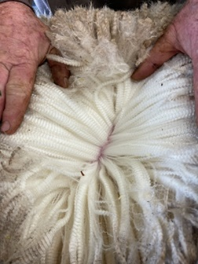
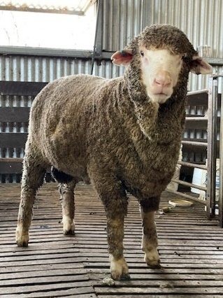  Tag 20.1 | 20.1 has number 1 tag for a reason. First son offered from 18.p087 our Reserve Champion.  Tag No 20.1  Sire Kerrilyn 18.p087  Micron SD CV CF  17.9 3.6 20.1 99.7 | 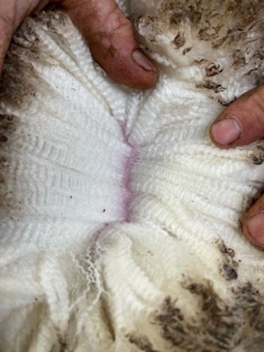
Tag 20.55  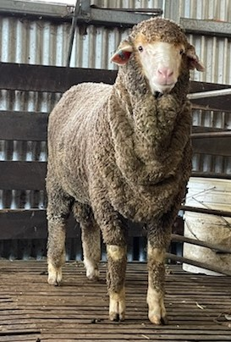 | 20.55 is a very similar ram to 20.1 with a very similar pedigree. Sired by 18.p100 another son of pink 44 out of a maiden ewe.  Tag No 20.55  Sire Kerrilyn 18.p100  Micron SD CV CF  18.3 3.7 20.2 99.5 | 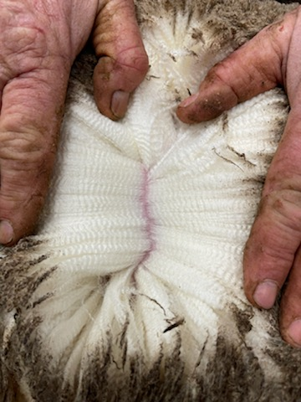
Tag 20.41  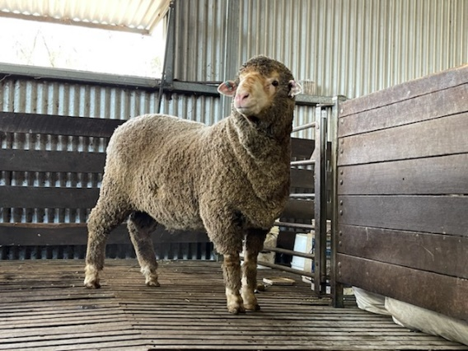 | 20.41 has a White River grandfather so has inherited a bigger body than the other 2 March shorn rams. Is a true dual-purpose sire with a big backside and a very good testing bold wool. Is the 2nd heaviest ram in his drop.  Tag No 20.41  Sire Kerrilyn 18.p087  Micron SD CV CF  21.4 2.7 12.6 99.7 | 